Q1. What is a computer?

Ans: - A computer is an electronic device that is used for storing and processing data, according to the provided instruction given by the user.

It can perform various types of tasks which makes work faster.

Computer are mainly divided in the following categories: -

1. Super computer
2. Mainframe computer
3. Mini Computer
4. Micro Computer
5. Personal Computer

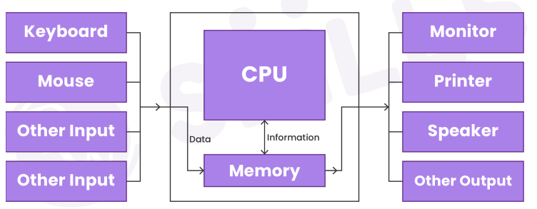

Fig:- computers work flow

Features of Computer:

**Speed: -** When executing mathematical computations, a computer works significantly faster and more accurately than a human. One billion instructions can be processed by computers every second. Computer operations take only a few nanoseconds or microseconds to complete.

**Accuracy: -** Calculations made by computers are always accurate. Data inaccuracy or consistency might lead to errors.

**Diligence: -** A computer has the constancy and accuracy to carry out countless jobs or calculations. It doesn't experience any drowsiness or lack of focus. It is also superior to human memory because of it.

**Versatility: -** The ability of a computer to carry out many tasks with the same level of accuracy and effectiveness is referred to as versatility.

**Reliability: -** When given the same set of data, a computer consistently produces the same output, so no matter how many times we input the same data, the outcome will remain the same.

**Automation: -** The computer completes every task automatically, that is, without human interaction.

**Memory**: - A computer has internal storage for data called primary memory. Data is also stored on removable media like CDs, pen drives, and other types of secondary storage.

Q2. What is RAM?

Ans: - RAM stands for Random Access Memory. It is a volatile memory means the information is kept in RAM while the computer is running, but is erased when the machine is powered off. We can only read files in this memory.

Q3. Where is data stored in a computer?

Ans: - The data is stored in computer in Primary memory like HDD, SDD, Pen-Drives etc.

Q4. What is that input devices used to type the text and numbers on a document in the computer system?

Ans: - Keyboard is used as input device to type text and numbers in computer system.

Q5. What are the output devices?

Ans: - An output device is any peripheral that receives data from a computer, usually for display, projection, or physical reproduction. Examples: - Monitor, Speakers, Printer, etc.

Q6. Which is the input device that allows a user to mover the cursor or pointer on the screen?

Ans: - Mouse and Joystick

Q7. Which language is directly understood by the computer without a translation program?

Ans: - Binary Language

Q8. What are input devices?

Ans: - Input devices are device which is used to insert commands in computer. Some example of input devices are: - Mouse, Keyboard, Joystick, etc.